Department of Management & Commerce Studies, MLCU
A Day at Rural Resource and Training Centre (RRTC), Umran
May 27, 2014

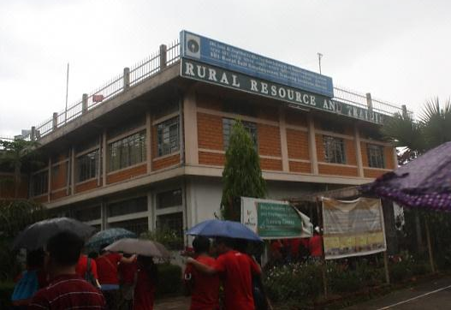
Sprawling over 145 hectares of land, RRTC is located at Umran under Ri-Bhoi District of Meghalaya. It is a training centre for farmers and school dropouts offering various courses. The centre itself is a model farm and housed a food processing unit.
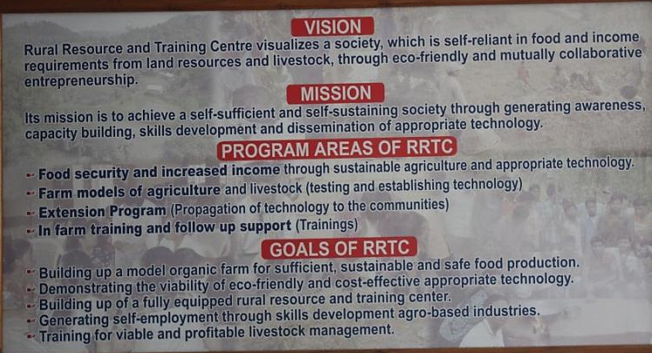
As part of the experiential learning, we set out for the centre by bus. It took us almost 2 hours from Shillong. On entering the administrative building, we were greeted by a huge display of Vision and Mission Statement of RRTC and different projects undertaken by the centre. Being a budding entrepreneur, who wants to run an organic farming based business, we knew this is going to be a resourceful and productive visit.
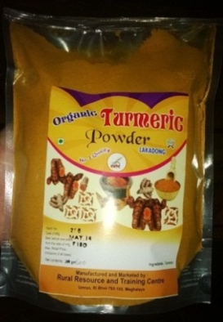
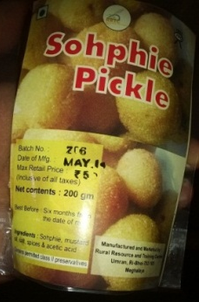
A pictorial step-by-step planting process of various commercial crops was on display for visitors. We also got the chance to watch a projected video walk-through which shows all the happenings and activities of the centre. Although rain played the spoilsport, it could not deter us from walking around the length and breadth of the centre where we experienced a multitude of farm from piggery to poultry and fishery to dairy. Not only this, we were also shown a vermi-compose facility. The vermi-compose (organic fertilizer) are sold to farmers. But the food processing unit is, by far, the most significant part of our visit. Different products ranging from turmeric powder, ginger candies, pickles, squash and fruit jam are processed in this unit. It was quite fascinating to see the products which are attractively packed and labeled; a food for thought for marketer. Upon further enquiry to the concerned marketing personnel, it was learnt that the products are distributed through retailers and all the striking labels and packages are printed at Don Bosco Technical Centre at Laitumkhrah (Shillong). A demonstration on bee-keeping was also done in our presence. We were told that just 1 kg of honey could easily fetch Rs. 500, a sound ROI (Return on Investment). Interestingly enough, we were enlightened by the fact that Bees are known to be aggressive towards red and black colour and temperatures ranging from below 15$℃$ to above 35$℃$. For a moment, there was a sense of fear and anxiety glooming all over our faces as red is the colour of our Department T-Shirt which we were wearing. But we were quickly assured that no harm will come to us as long as the bees are handled with calm and care.
Overall, the visit enriched our knowledge on commercial farming. A lot was stressed on scientific based farming over traditional method to generate maximum return. It gave us a broader picture on how Entrepreneurship Development could be started through many available resources. Indeed, it was fruitful practical learning experience for all of us.

- Inputs from Lian Khan Siam and Bansiew Mylliemngap, MBA II Semester Students

